You and your partners are required to video record each component of the project below using a phone, camera, tablet, or computer. You will explain the steps you are taking to complete the constructions as you complete them. The camera angle should be able to capture the student’s face and hands while completing the construction, as well as the paper the construction is being done on. Your partner can help get the correct camera angle while you complete the construction. You will switch roles after each component. The finished product should be one video containing 2 components completed by each partner. It needs to be uploaded to the google drive folder (link on weebly) by 11:59pm on Tuesday, September 12th. You will also turn in this completed sheet to me on Wednesday, September 13th. The person who completed the component should sign their name next to their drawing.
Complete the following below. Leave all construction marks on the paper. We need to see the construction marks to give you any credit. Freehand will not be accepted. Label the new figure!
- Construct segment CD congruent to segment AB.

- Construct an angle equal to the m<2 + m<3.
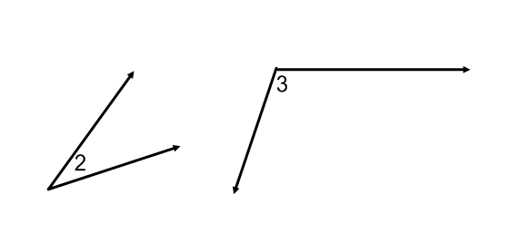

- Construct triangle ABC congruent to triangle DEF. (Hint: all corresponding sides and corresponding angles have to be congruent to each other. For example: side AB on the old triangle is congruent to side DE on your new triangle.) Use Point P to begin your construction.
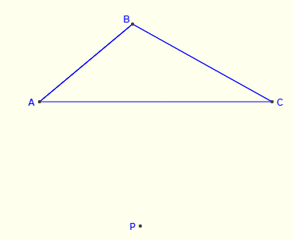

- Construct a 45 degree angle.

- Construct a segment 3/2 the size of segment AB.

- Construct an isosceles triangle given the base and the altitude. Use Point P to begin your construction.
